TEST PLAN

**Contact List**

*ChangeLog*

|  |  |  |  |
| --- | --- | --- | --- |
| **Version** | **Change Date** | **By** | **Description** |
| 1.0 | 18.03.2025 | Adi Smajić | Created Test plan |
| 1.1 | 18.03.2025 | Adi Smajić | Added sceleton content |
| 1.2 | 19.03.2025 | Adi Smajić | Added all Test scenarios and steps |
| 1.3 | 19.03.2025 | Adi Smajić | Added Bug scenarios |
| 1.4 | 19.03.2025 | Adi Smajić | Added Description |
| 1.5 | 19.03.2025 | Adi Smajić | Added other features |

Table of Contents

Test Prerequisites and Data 4

Diagram 4

Test Criteria 4

Abortion of testing 4

Exit Criteria 4

Limitations 4

Test Methodologies 4

Test Automation 4

Test Environment and Tools 4

Estimation 4

Terms / Acronyms 4

Project description / user flow 5

Test sets 5

Features/Parts To Be Tested (In Scope) 5

Features That Won’t Be Tested (Out of Scope) 5

Defects Handling 5

**Test set Execution** 5

USE CASE 1: Home page 5

TC no. 01: Verify the user can successfully register a new profile. 5

TC no. 02: Verify the user can’t register a new profile using invalid inputs. 5

TC no. 03: Verify user can’t register a profile with an existing email address. 5

TC no. 04: Verify the user can successfully log in using an existing profile. 5

TC no. 05: Verify the user can’t log in using invalid inputs. 5

TC no. 06: Verify the user can successfully log out. 5

TC no. 07: Verify the contact list is saved after the user logs out. 5

TC no. 08: Verify the user can cancel the Sign in page. 5

USE CASE 2: Contact list page 5

TC no. 01: (Performance Test) Verify user can add 500 contacts to the list. 5

TC no. 02: Verify the user can successfully add a new contact with mandatory fields. 5

TC no. 03: Verify the user can successfully add a new contact with all fields. 5

TC no. 04: Verify the user can’t add a new contact with invalid inputs. 5

USE CASE 3: Contact details page 6

TC no. 01: Verify the user can cancel the Add Contacts page. 6

TC no. 02: Verify the user can cancel the Edit Contacts page. 6

TC no. 03: Verify the user can successfully delete an existing contact. 6

TC no. 04: Verify the user can successfully edit an existing contact 6

**Test Documentation info** 6

**Bug report & UI/UX issues:** 6

**Issue no. 01: (UX) Adjust the error message for incorrect Log in.** 6

**Issue no. 02: (UX) Adjust the error message for incorrect Sign up.** 6

**Issue no. 03 (UX) Add mandatory icons for input fields in Sign up page.** 6

**Issue no. 04 Provide the user the ability to delete their profile.** 6

**Issue no. 05 User is not able to change their password.** 6

**Issue no. 06 (UX) Add a view icon next to password input fields.** 6

**Issue no. 07 (UX) Investigate what field values can’t be used for two different contacts.** 6

**Issue no. 08 Logged out users can access the Contact List pages.** 6

**Issue no. 09 (UX) Hide the password value in the Sign-up error message.** 6

**Issue no. 10 (UX) Change the Date of Birth format for contacts.** 6

## Test Prerequisites and Data

Before testing phase:

- Test plan document.

- Test cases documented.

- Test design specifications.

- Behavior diagram

Preconditions for the start of the testing phase:

**Active URL:** https://thinking-tester-contact-list.herokuapp.com/

**Test Data:** /

During testing phase:

- Test Tools specified.

- Simulators (N/A).

- Test Data verified (N/A).

- Error logs and execution logs (N/A).

After testing phase:

- Test Results/reports.

- Defect Reports.

- Running automated tests.

## Diagram

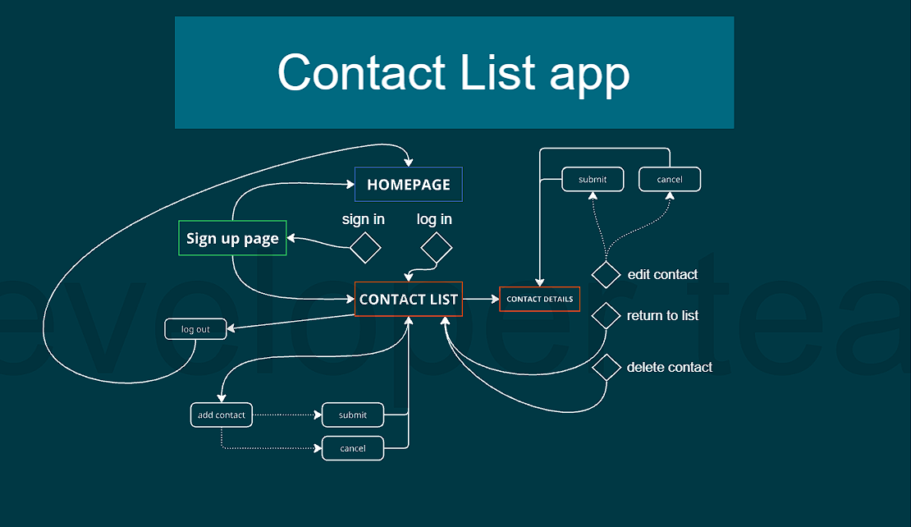

# Test Criteria

Testing will be considered complete when the following conditions have been met:

• 100% test coverage

• All Manual Test cases executed

• All Automated Test cases executed

## Abortion of testing

If the tester reports that at least one high priority test cases failed, he will immediately suspend testing until the developers fix all bugs and issues.

If the main tester reports >**50%** of the medium priority test cases failed, he will immediately suspend testing until the developers fix all bugs and issues.

No criteria for the low priority bugs/issues as they can be updated over a period of time.

## Exit Criteria

No present bugs/issues in the high priority level.

No more than 50% remaining medium priority bugs/issues to be fixed.

# Limitations

|  |  |
| --- | --- |
| **Limitations** | **How to overcome them** |
| No access to database | Existing test data will be used |
| No mobile application | Continue the test using web browsers |

# Test Methodologies

For the Contact List app website there’re 3 main types of testing that should be conducted:

1. Positive/Negative testing
2. Non-functional testing
3. Automated tests

|  |  |
| --- | --- |
| Name: | Description: |
| **UX testing** | Analyzing the flow of the application and usability as a form of quality measures for the design. |
| **Exploratory testing** | Simultaneous learning, test design and test execution. |
| **Monkey testing** | Quick testing by the QA not familiar with the website. Repeating flows over and over again. |
| **Automated tests** | Writing and executing the automated test previously documented as TC in this document |
| **Smoke test** | Testing the main and most important user functionalities of the website. Ensuring the successful user experience from start to end. |

## Test Automation

Automated functional test is planned at this time. The main goal of automation testing is to ensure that all functionalities work in accordance with certain requirements. It can significantly reduce the time it takes to test products because it runs quickly and efficiently. This puts time back into the hands of developers and production managers, who can divert their efforts into other aspects of the project. It can greatly boost productivity as a result.

# Test Environment and Tools

As of now, a mobile application of the Contact list app is not used by the Tester. In that case, our focus is on the web browsers and different devices (desktop/tablet/mobile).

We will cover most popular web browser during our testing (and additional if required).

|  |  |
| --- | --- |
| Process | Tool |
| **Defect Tracking** | MS Word |
| **Test Cases** | MS Word |
| **Automation Framework & Tool** | Chai, Mocha, Cypress |
| **Programming language** | Javascript |
| **Operative system** | Windows 10/Android 13 |
| **Browser** | Google Chrome, Firefox, Safari |

Main test environment

|  |  |
| --- | --- |
| Name: | Version: |
| Google Chrome | 134.0.6998.89 |

# Estimation

2 days

# Terms / Acronyms

| TERM/ACRONYM | DEFINITION |
| --- | --- |
| TC | Test Case |
| Precondition | A necessary action/data before the execution of the TC |
| Data | Pre-generated string from the QA that is used in the TC (optional) |
|  |  |

# Project description / user flow

Contact List App is a web-based application that allows users to create and store contacts within their Contact list. If the user enters the page for the first time, the prerequisite is to Sign up to create a new profile with the name, last name, email and password as mandatory fields.

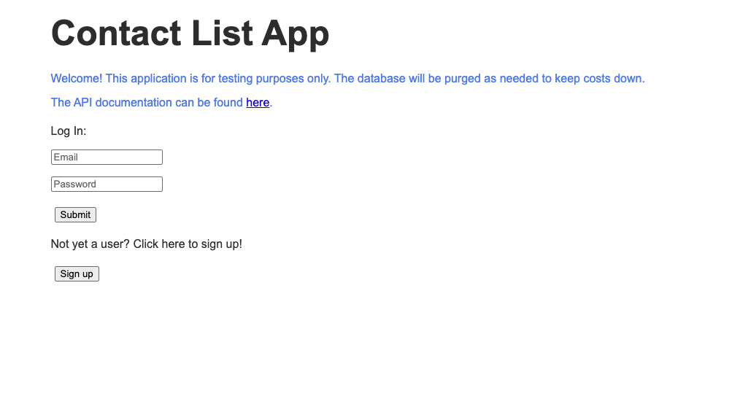

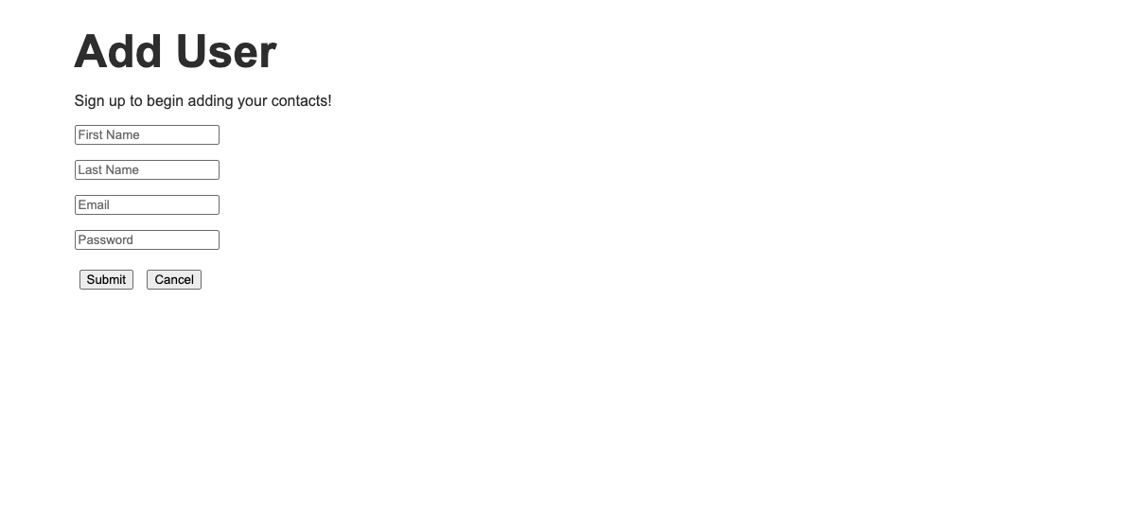

When the user is logged in with a new profile, an empty table with different columns is presented.  
  
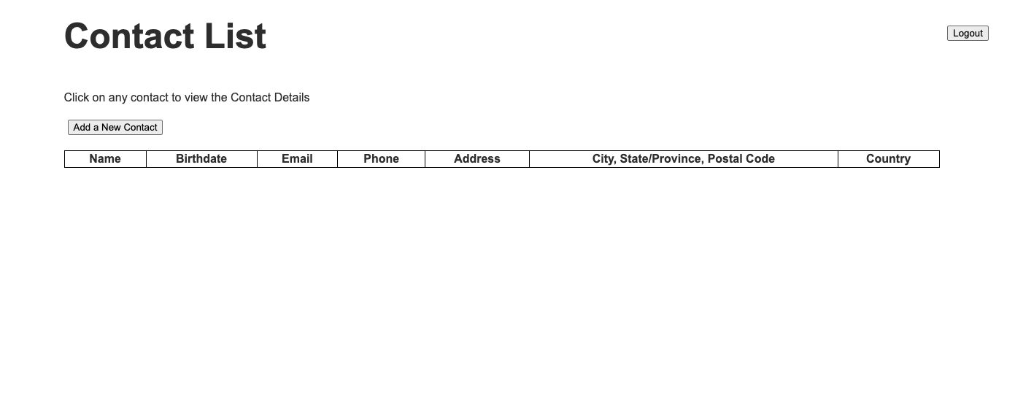

A new contact can be added using the namesake button above the table. The first and last name are the only mandatory fields. The submit button publishes the new contact and returns the user to the table that shows all changes for each column.

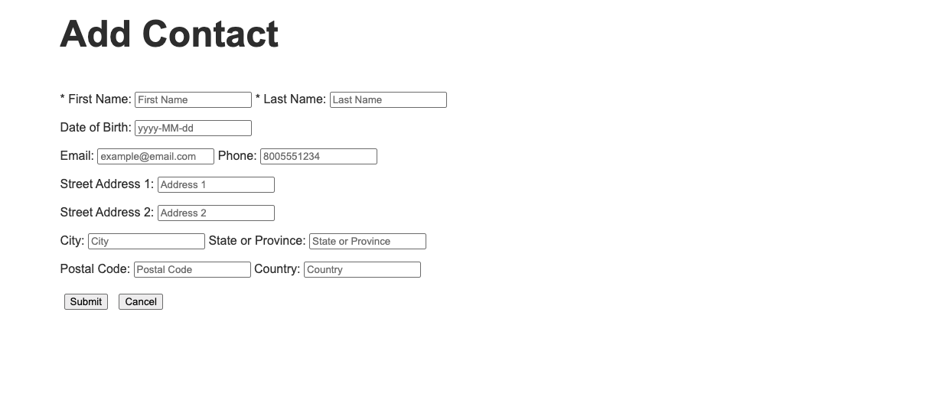

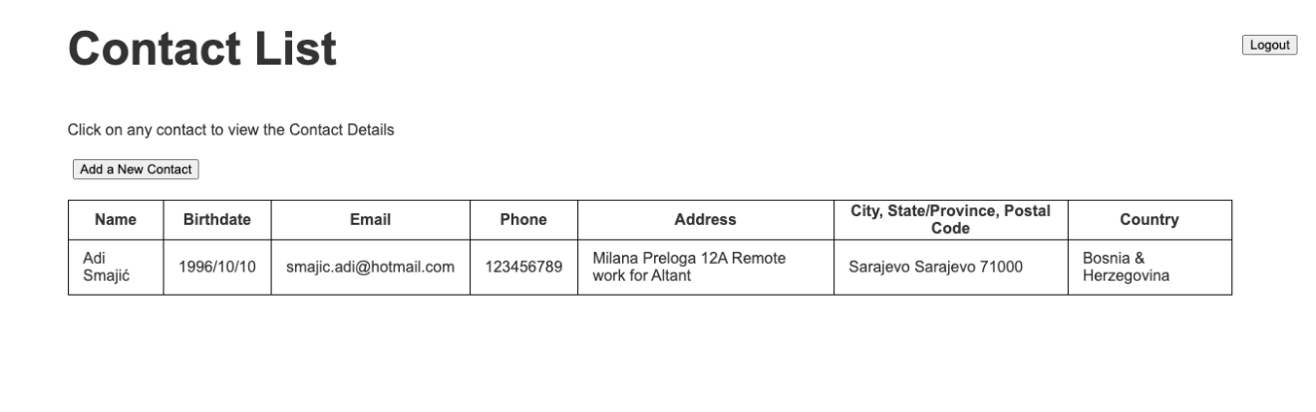

The existing contact can be accessed again in order to make some new changes/edits or to delete it. If the user deletes the contact, the application will navigate to the updated table, now without the deleted contact.

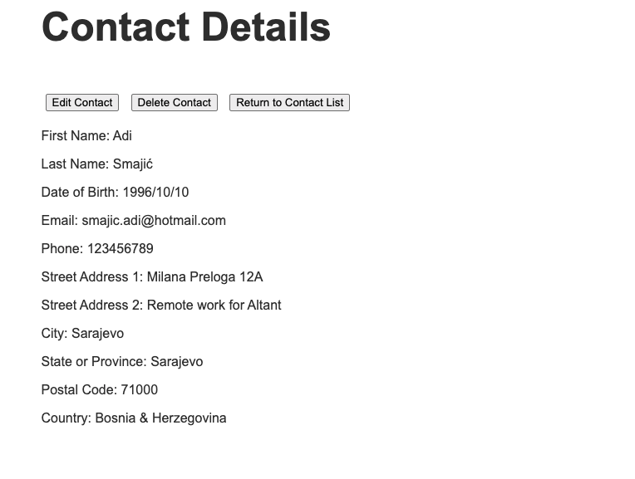

In the end, the user can decide to log out using the button located in the top right corner, after which the application navigates again to the homepage. With the previously created profile, the user can now directly sign in using existing credentials (email, password). All previously created contacts, that were not deleted, should be shown inside the table.

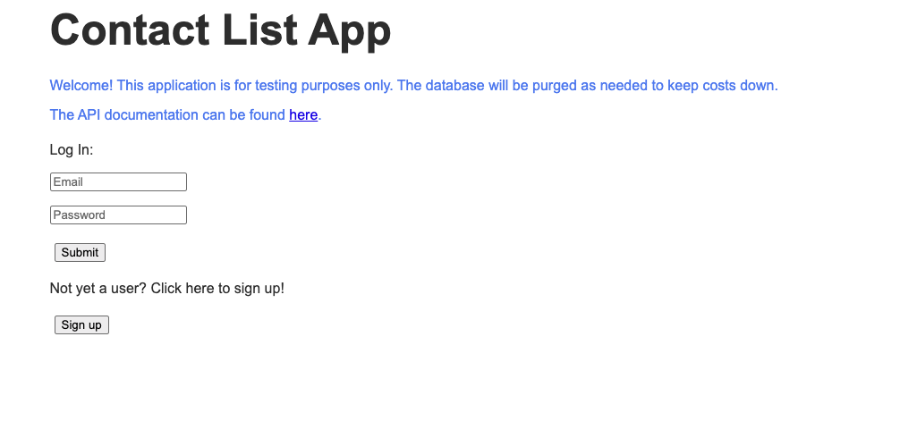

# Test sets

USE CASE 1:

* Home page

USE CASE 2:

* Contact list page

USE CASE 3:

* Contact details page

# Features/Parts To Be Tested (In Scope)

* Sign in, Log in, Log out
* Adding new Contacts
* Editing and removing existing contacts
* Interaction between different pages
* Layout, responsiveness
* The user experience

# Features That Won’t Be Tested (Out of Scope)

* Database entries and modification on the backend
* Email validation
* Performance/Stress tests
* UI

# Defects Handling

N/A

|  |  |  |  |  |  |
| --- | --- | --- | --- | --- | --- |
| Type of Defects | Functionality | Performance | Security | Usability | Compatibility |
| Critical | x | x | x | x | x |
| Major | x | x |  | x | x |
| Normal |  | x |  | x | x |
| Low |  |  |  | x |  |

Severity vs Priority

Severity low/normal/high  
Priority low/normal/high

Example:

Low Severity but high Priority – the logo image of the founder is not visible on the homepage.  
  
The application is still fully functionable, and for the user there is no error preventing a normal user flow. While on the other hand, the user should we aware of the creator for the application, the logo might be hyperlinked to an external website showing other products too.

# **Test set Execution**

## USE CASE 1: Home page

### TC no. 01: Verify the user can successfully register a new profile.

**Precondition:** Open website <https://thinking-tester-contact-list.herokuapp.com/>

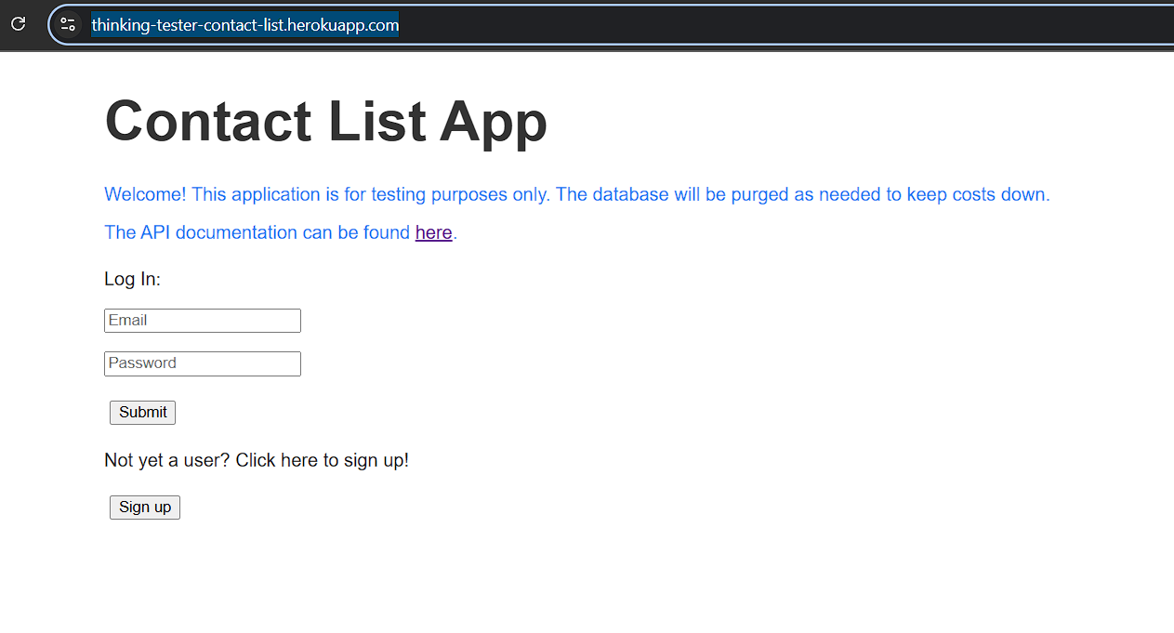

**Steps:**

1) Click on the Sign up button located below the “Not yet a user?...” text.  
  
Verify the user is navigated to the Add user page.

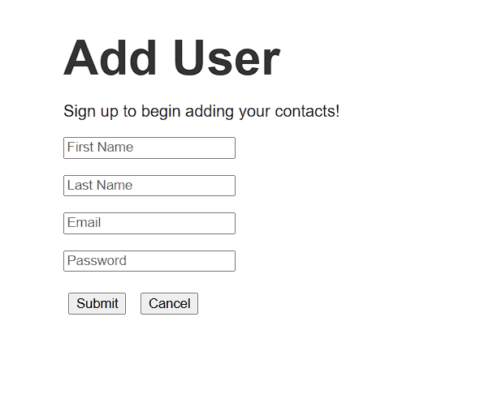

2) Fill in all fields (First Name, Last Name, Email and Password)  
  
The email field needs to have the correct email format (something@something.domain).  
The password field requires at least 7 characters.  
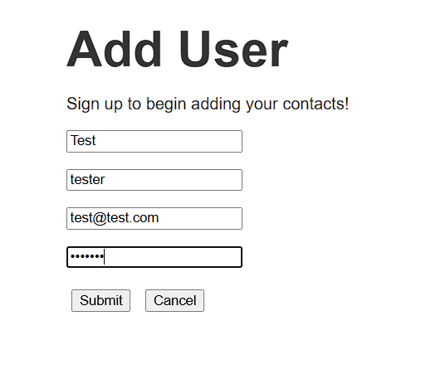

3) Click on the Submit button

Verify the user is navigated to the Contact list page.  
Verify the contact table is empty  
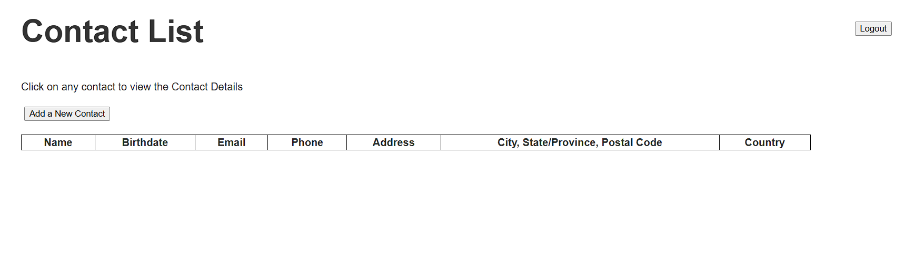

### TC no. 02: Verify the user can’t register a new profile using invalid inputs.

**Precondition:** Open website <https://thinking-tester-contact-list.herokuapp.com/>



**Steps:**

1) Click on the Sign up button located below the “Not yet a user?...” text.  
  
Verify the user is navigated to the Add user page.



2) Click on the Submit button

Verify an error message is shown that all fields are missing or are invalid.

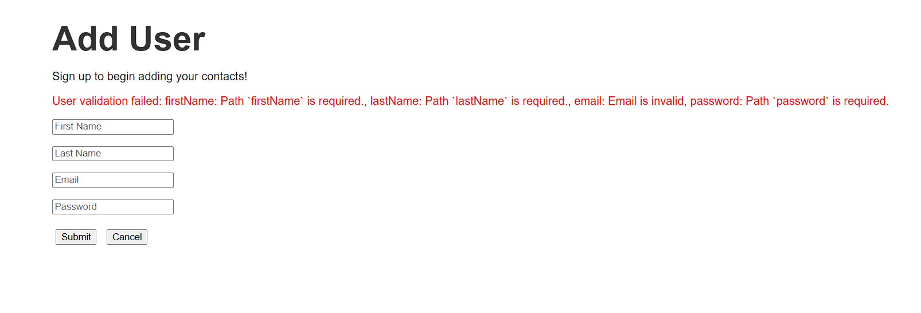

3) Enter the First name and click on the Submit button

Verify the error message is again shown, but without the missing first name field  
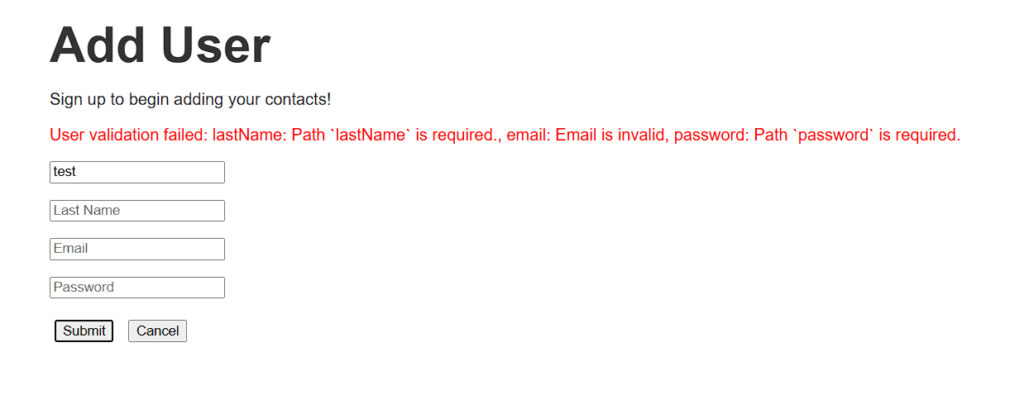

4) Enter the last name and click on the Submit button

Verify the error message is again shown, but without the missing first name and last names fields

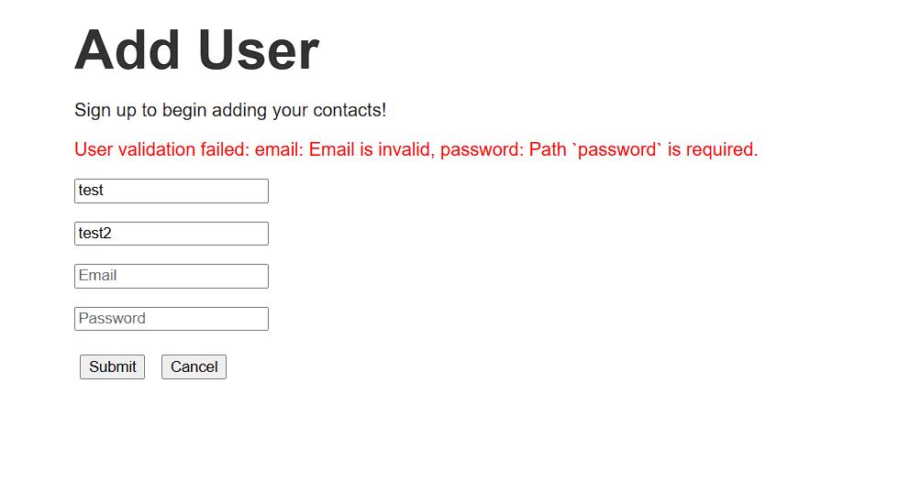

5) Enter an invalid Email

data: test  
data: @test.com  
data: [test@.com](mailto:test@.com)  
data: test@test

and click the Submit button

Verify the error message is again shown with the email being invalid every time

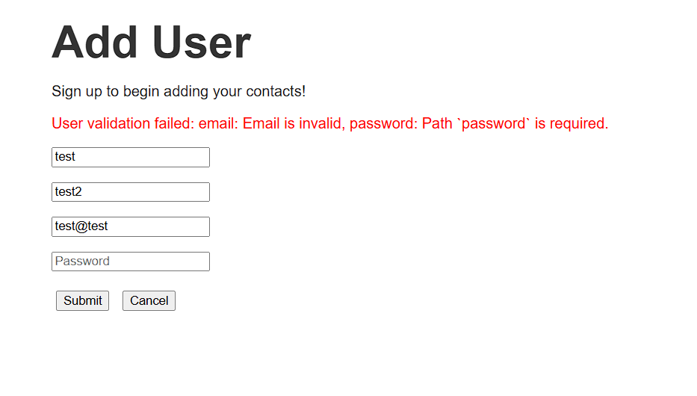

6) Enter a valid email, and enter a password with max 6 characters  
  
Verify the error message is shown saying that the password is shorter than the minimum length.

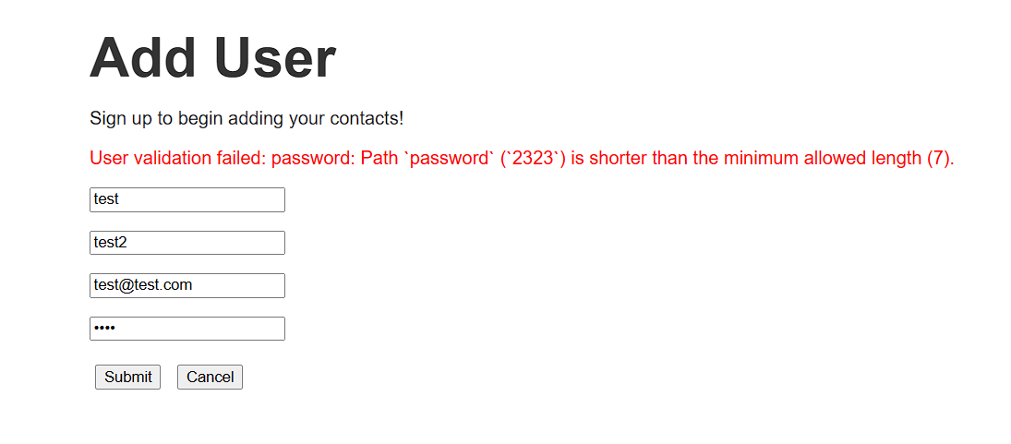

### TC no. 03: Verify user can’t register a profile with an existing email address.

**Precondition:** Execute TC no. 01



**Steps:**

1) Click on the Sign up button located below the “Not yet a user?...” text.  
  
Verify the user is navigated to the Add user page.



2) Fill in all fields (First Name, Last Name and Password).  
3) Enter the previously used Email address from TC no. 01.  
4) Click on Submit button.  
  
Verify an error message is shown saying that the Email address is already in use

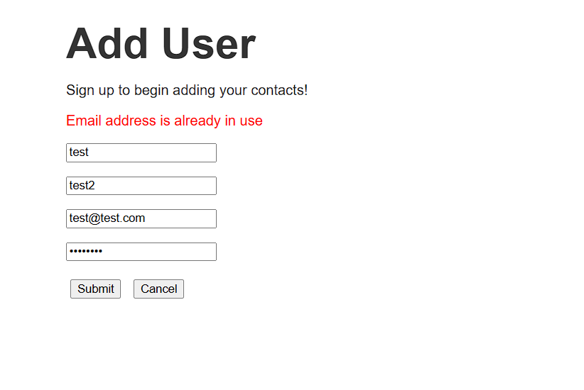

### TC no. 04: Verify the user can successfully log in using an existing profile.

**Precondition:** Execute TC no. 01  
data:   
email [test@test.com](mailto:test@test.com)  
password: 1234567

**Steps:**

1) Open website <https://thinking-tester-contact-list.herokuapp.com/>



**2)** Enter the existing Email in the Email input field  
3) Enter the password in the Password input field  
4) Click on the Submit button

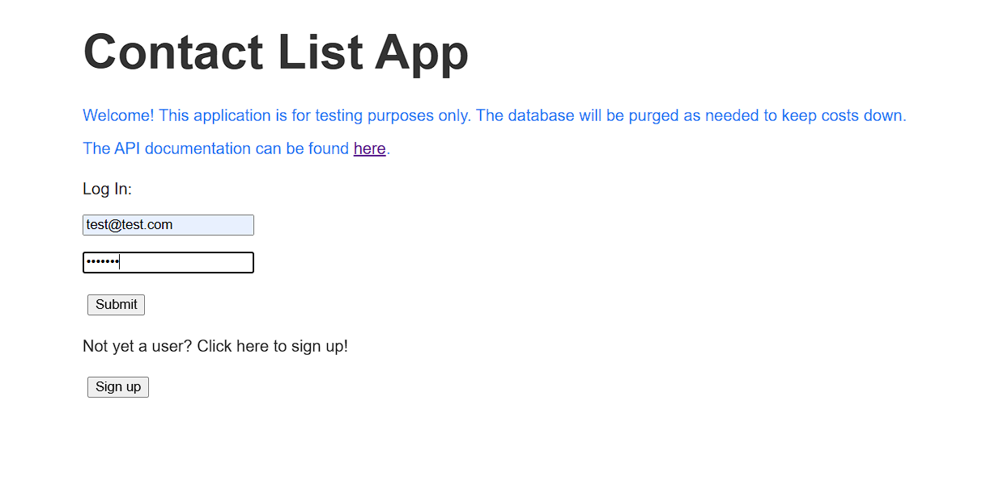

Verify the Contact list page successfully opens with an empty table

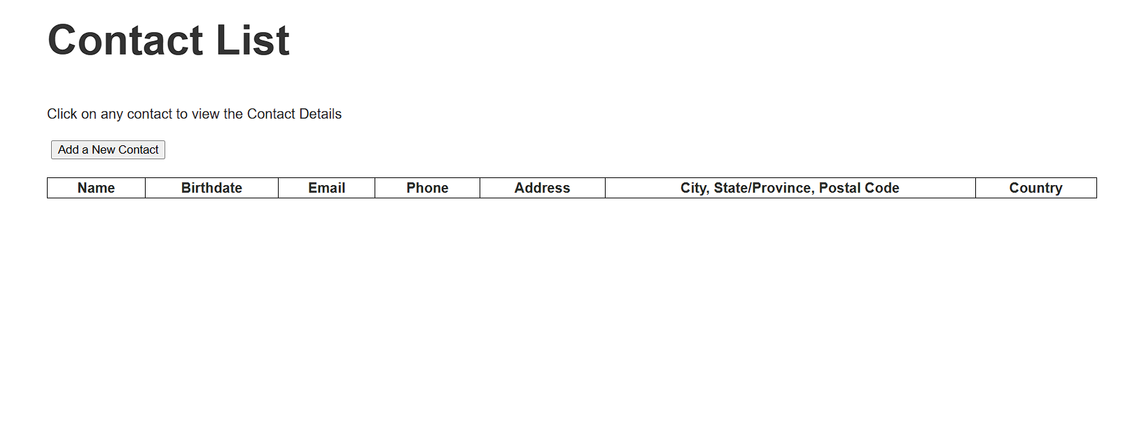

### TC no. 05: Verify the user can’t log in using invalid inputs.

**Precondition:** Open website <https://thinking-tester-contact-list.herokuapp.com/>



**Steps:**

1) Click on Submit button

Verify the error message appears saying Incorrect username or password

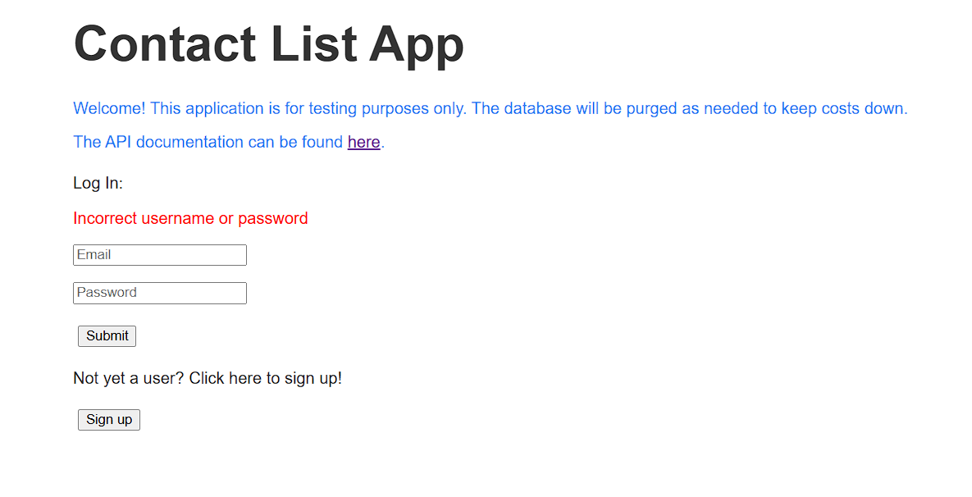

2) Enter an invalid email, click on the Submit button.  
  
Verify the error message appears saying Incorrect username or password

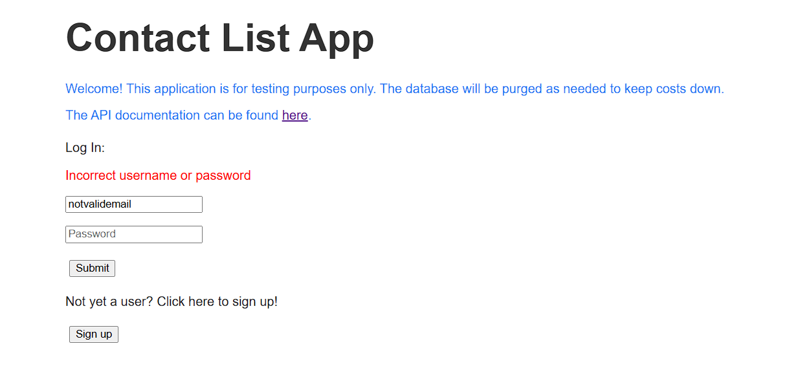  
  
  
3) Enter an invalid password, click on the Submit button.  
  
Verify the error message appears saying Incorrect username or password

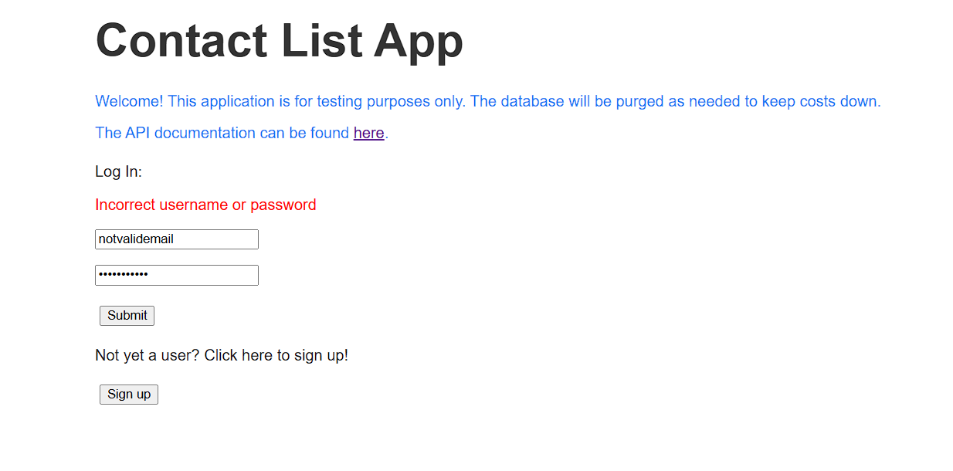  
  
4) Enter a valid email address but invalid password, click on the Submit button.

Verify the error message appears saying Incorrect username or password

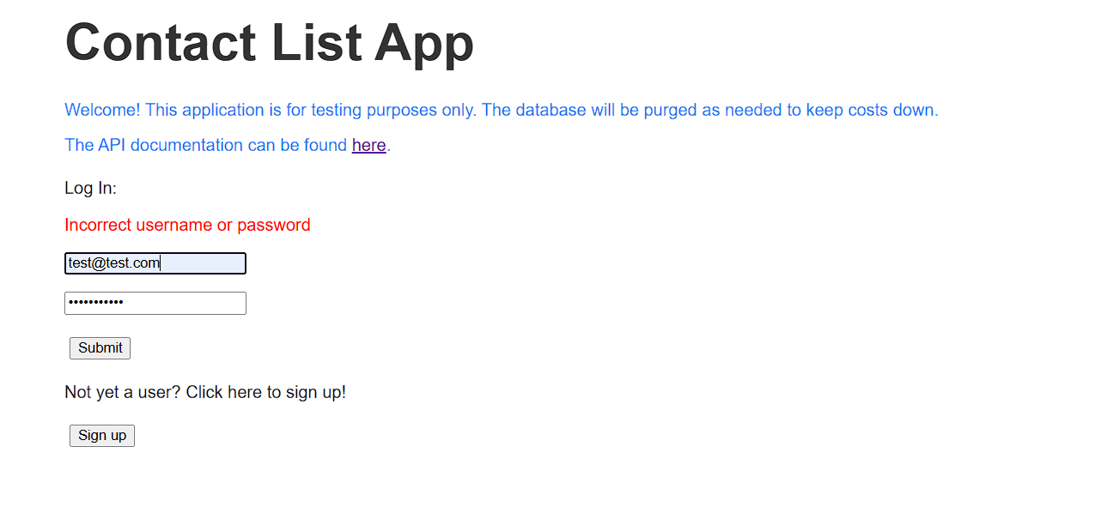

5) Enter an invalid email address but valid password, click on the Submit button.

Verify the error message appears saying Incorrect username or password

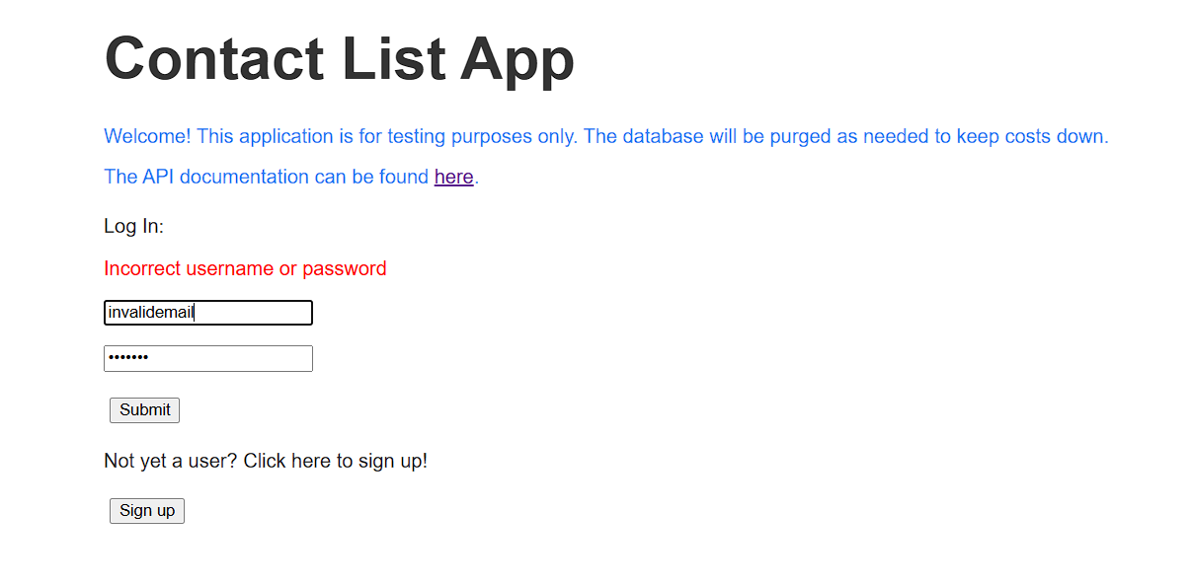

### TC no. 06: Verify the user can successfully log out.

Precondition: Execute TC no. 04  
  
Steps:

1) While on the Contact List page, click on the Logout button located in the top right corner

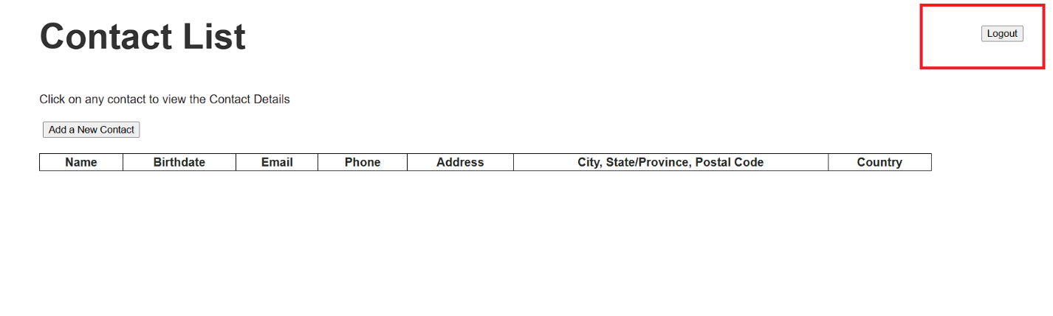

Verify the user is navigated to the Log in homepage



### TC no. 07: Verify the user can cancel the Sign in page.

**Precondition:** Open website <https://thinking-tester-contact-list.herokuapp.com/>



**Steps:**

1) Click on the Sign up button located below the “Not yet a user?...” text.  
  
Verify the user is navigated to the Add user page.



**2)** Fill in all fields and click on the Cancel button

Verify the user is navigated back to the homepage



## USE CASE 2: Contact list page

### TC no. 01: Verify the user can successfully add a new contact with mandatory fields.

Precondition: Execute TC no. 04 from USE CASE 1

Steps:  
  
1) Click the add a new contact button  
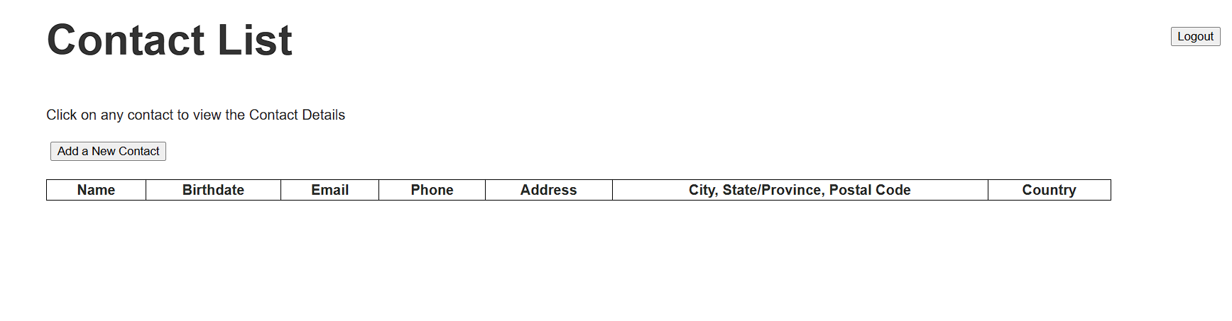

Verify the user is navigated to the Add Contact page

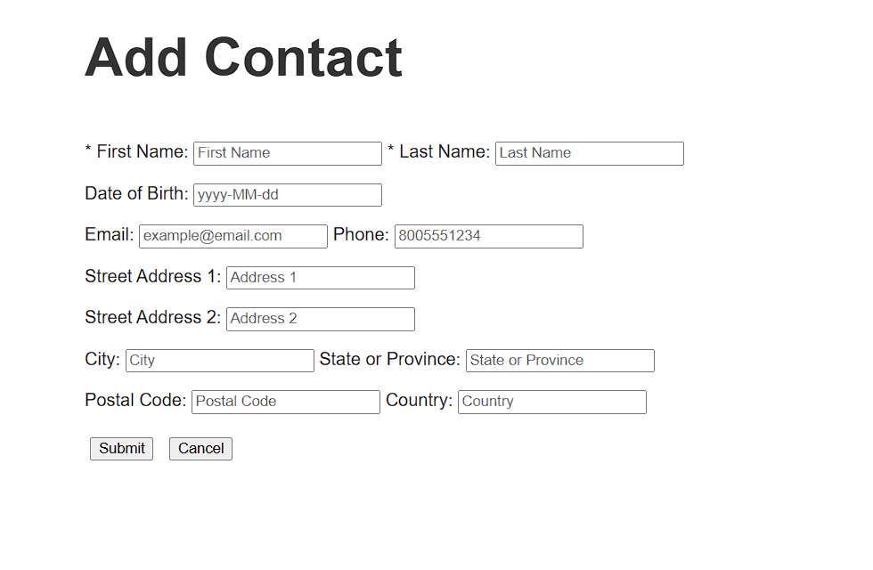

**2)** Fill in only the mandatory fields (First name, Last name) and click on Submit button.

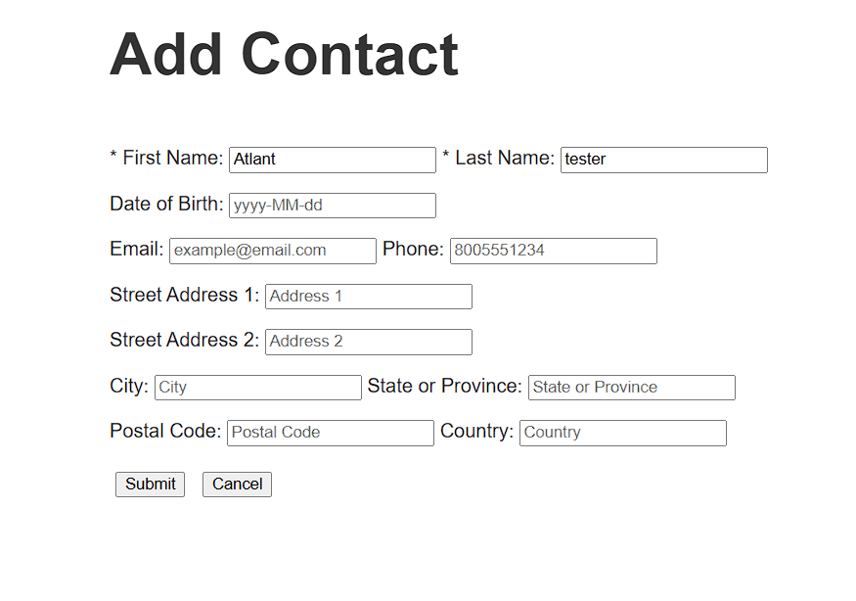

Verify the user is navigated back to the Contact List page and the table is updated with the new contact

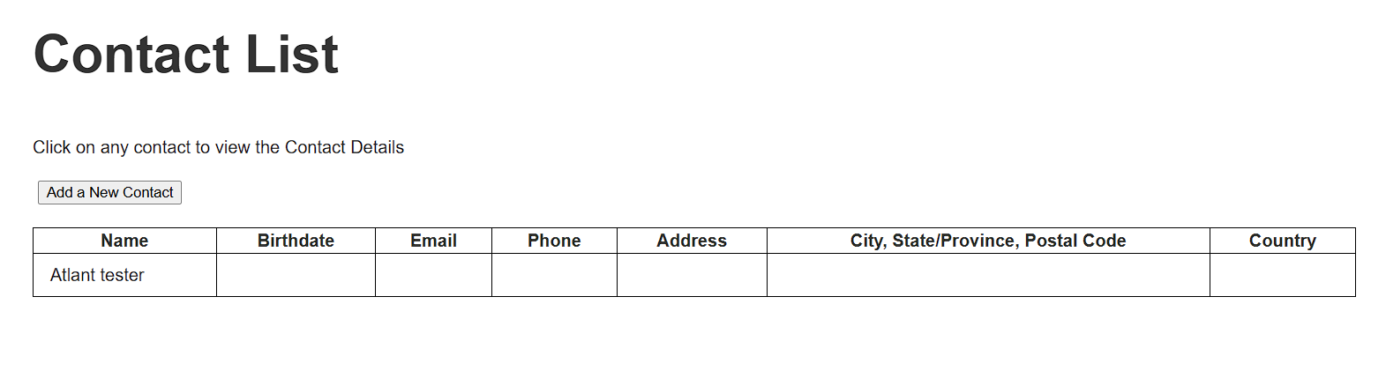

### TC no. 02: Verify the user can successfully add a new contact with all fields.

Precondition: Execute TC no. 04 from USE CASE 1

Steps:  
  
1) Click the add a new contact button  


Verify the user is navigated to the Add Contact page



**2)** Fill in all fields with valid inputs as seen in the preview below.

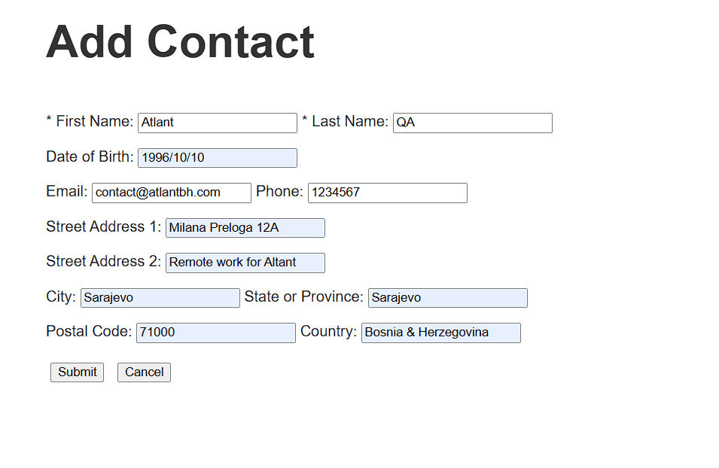

3) Click on Submit button.

Verify the user is navigated back to the Contact List page and the table is updated with the new contact

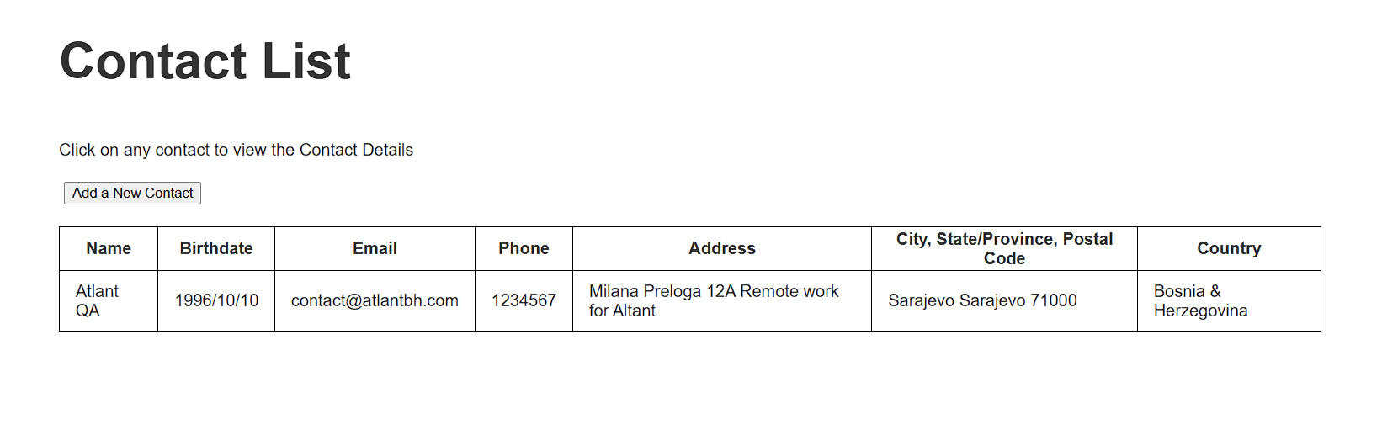

### TC no. 03: (Performance Test) Verify user can add 500 contacts to the list.

Precondition: This test needs to be automated.

Steps:

1) Execute TC no. 03 with different value 500 times  
  
Verify all contacts are successfully added to the table.

### TC no. 04: Verify the user can’t add a new contact with invalid inputs.

Precondition: Execute TC no. 04 from USE CASE 1

Steps:  
  
1) Click the add a new contact button.  


Verify the user is navigated to the Add Contact page



2) Click on the Submit button.  
  
Verify the error message saying that first name and last name are missing.

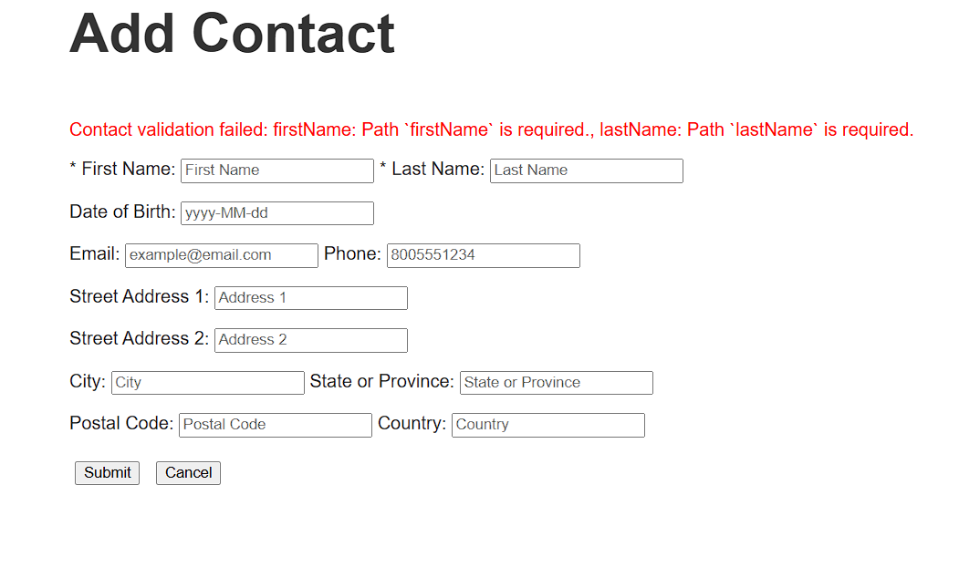

3) Add a valid first name and click the submit button again.

Verify the same error message asking for the last name

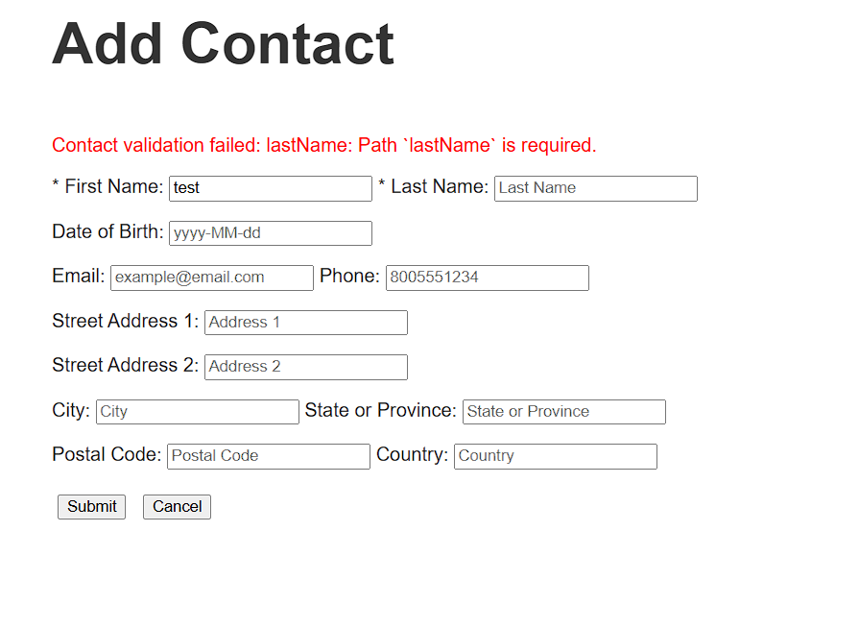

4) Enter the last name, remove the first name and click the submit button

Verify the same error message asking for the first name

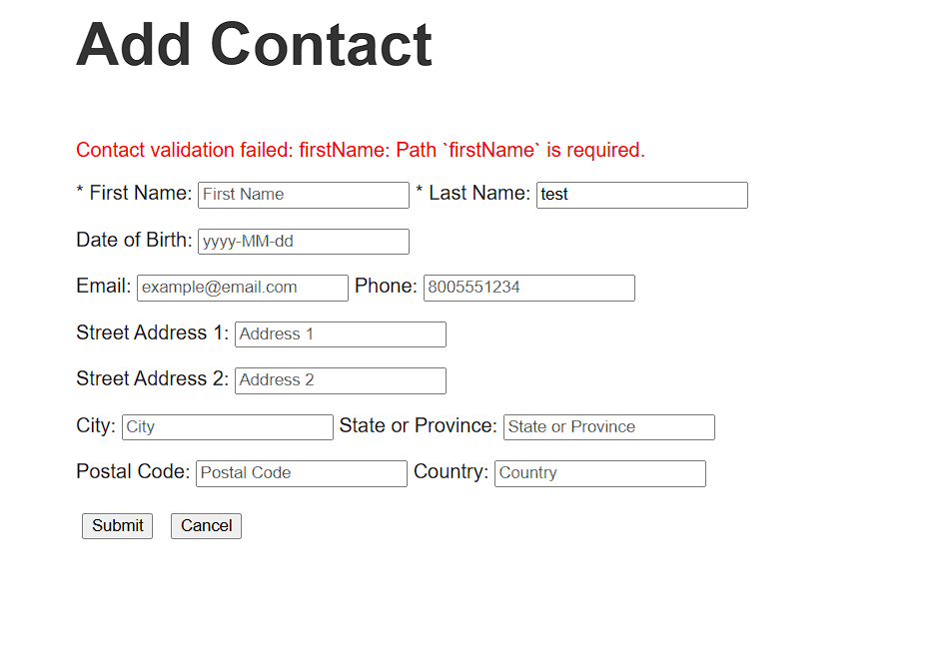

5) Enter the first and last name, enter an invalid date format:

test  
13/04/1996  
1234567

Verify the error message saying that the Birthdate is invalid

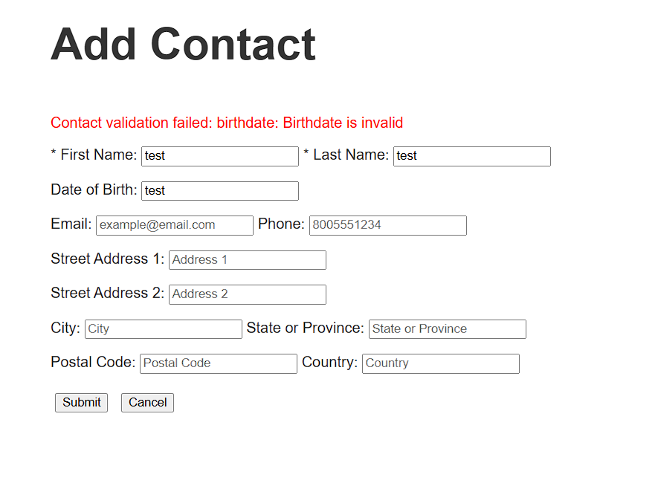

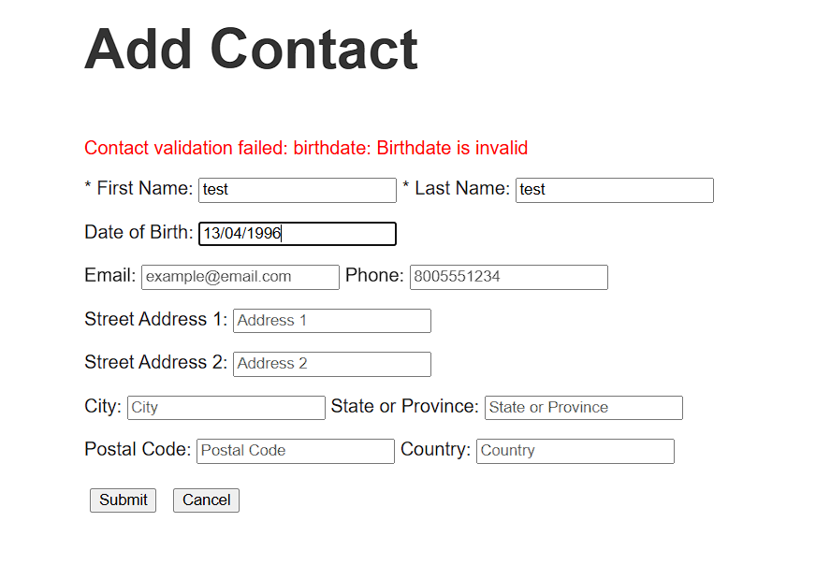

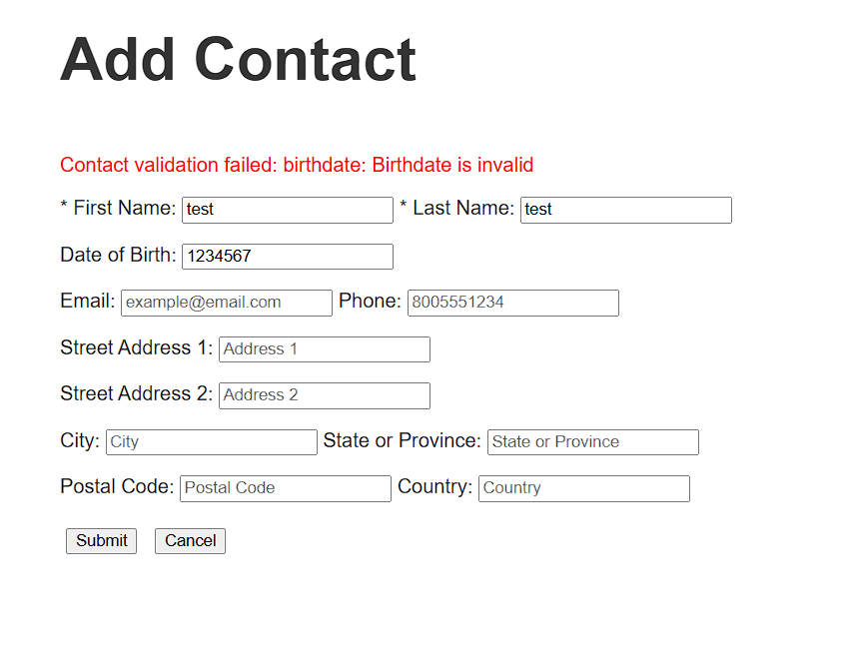

6) Enter a valid date of birth (1996/13/04), enter an invalid phone number (letters), click on the submit button

Verify the error message saying that the phone number is not valid

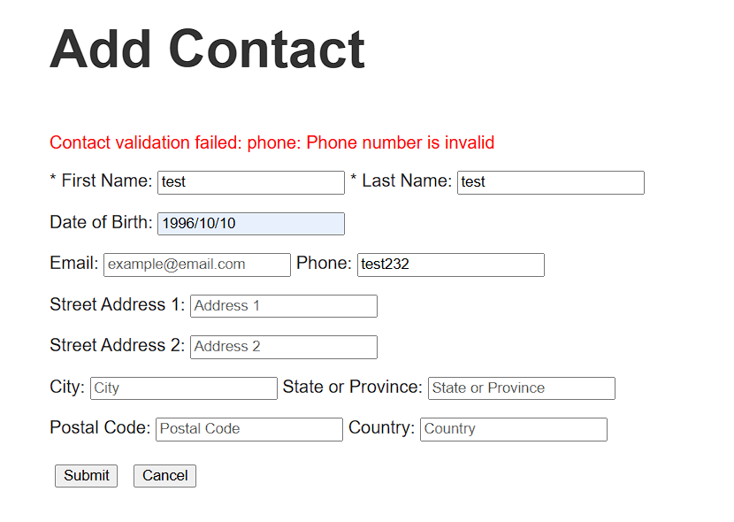

7) Enter a valid phone number. Enter an invalid email address.  
  
data:  
test  
[test@.com](mailto:test@.com)  
test@test  
[@test.com](mailto:test@.com)

Verify the error message saying that the email address is not valid

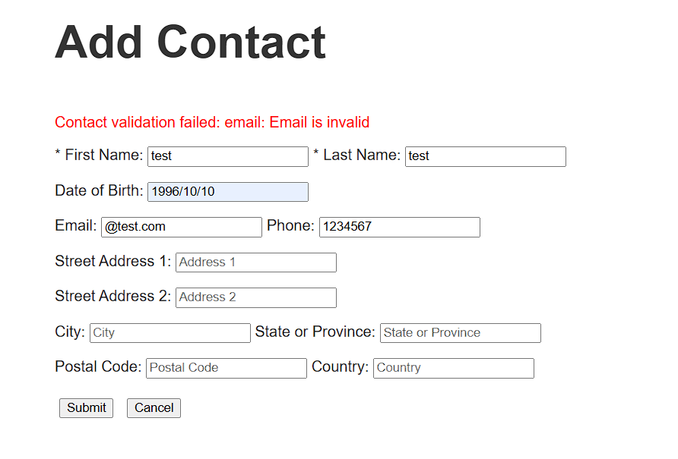

### TC no. 05: Verify the contact list is saved after the user logs out.

Precondition: Execute TC no. 03 from USER CASE 2

Steps:  
  
1) Observe the current Contact List.  


2) Click on the Log out button located in the top right corner.

Verify the user is navigated back to the Log in homepage



3) Insert the existing email and password from the previous profile and click the Submit button.

Verify the user is navigated back to the Contact list and the table is showing the same contacts



## USE CASE 3: Contact details page

### TC no. 01: Verify the user can cancel the Add Contacts page.

Precondition: Execute TC no. 04

Steps:  
  
1) Click the add a new contact button  


Verify the user is navigated to the Add Contact page



**2)** Fill in all fields and click on the Cancel button.

Verify the user is navigated back to the Contact List page with an empty table



### TC no. 02: Verify the user can cancel the Edit Contacts page.

**Precondition:** Execute TC no. 08



Steps:  
  
1) Click on the row containing the existing contact, on any value.

Verify the Contact Details page opens

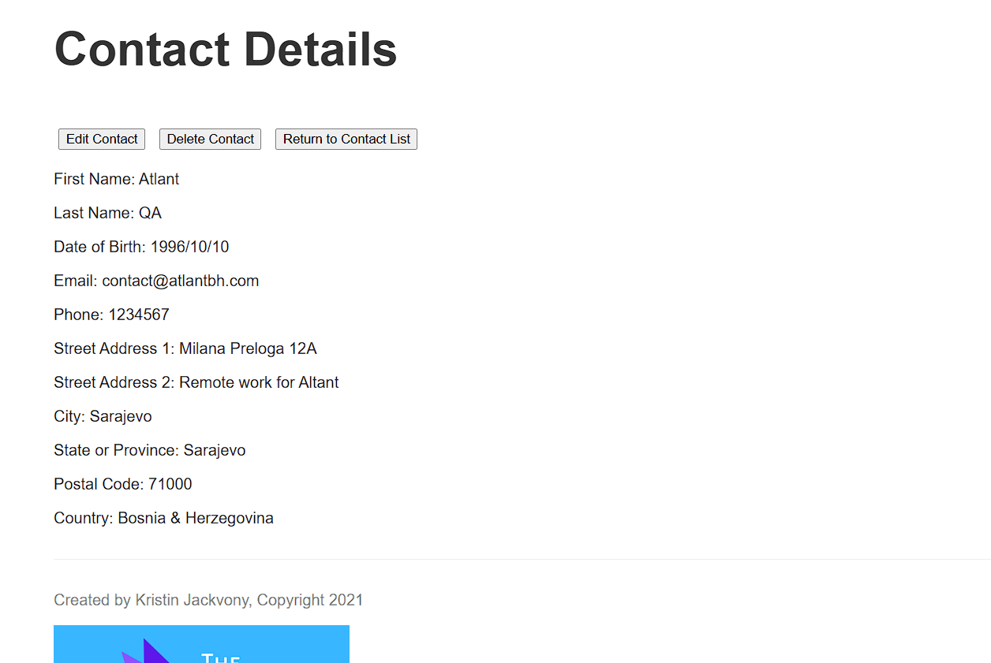

2) Click on the Edit contact button

Verify the Edit Contact page opens

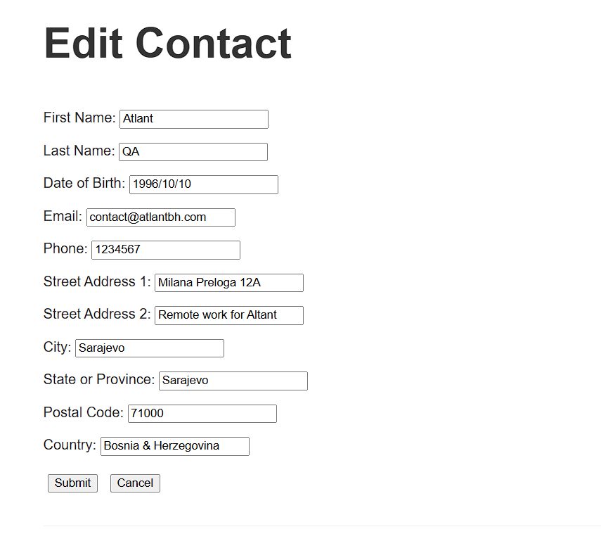

3) Click on the Cancel button

Verify the user is navigated back to the Contact Details page



### TC no. 03: Verify the user can successfully delete an existing contact.

**Precondition:** Execute TC no. 08



Steps:

1) Click on the row containing the existing contact, on any value.

Verify the Contact Details page opens



2) Click on the delete contact button

Verify a pop up appears asking the user to delete the contact. Click on Ok

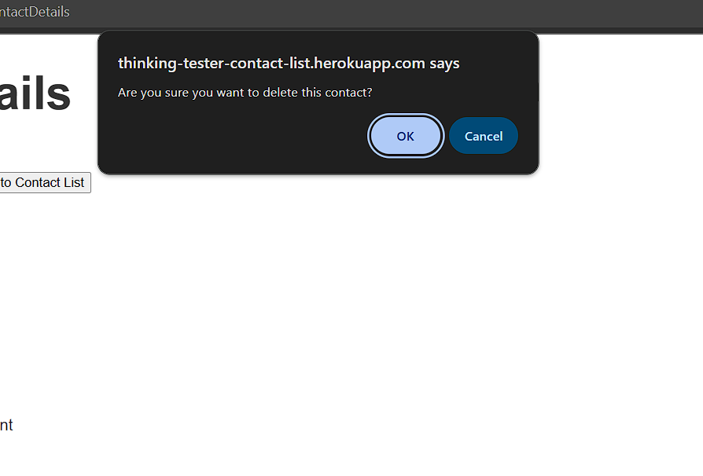

Verify user is navigated back to the Contact List with an empty table.

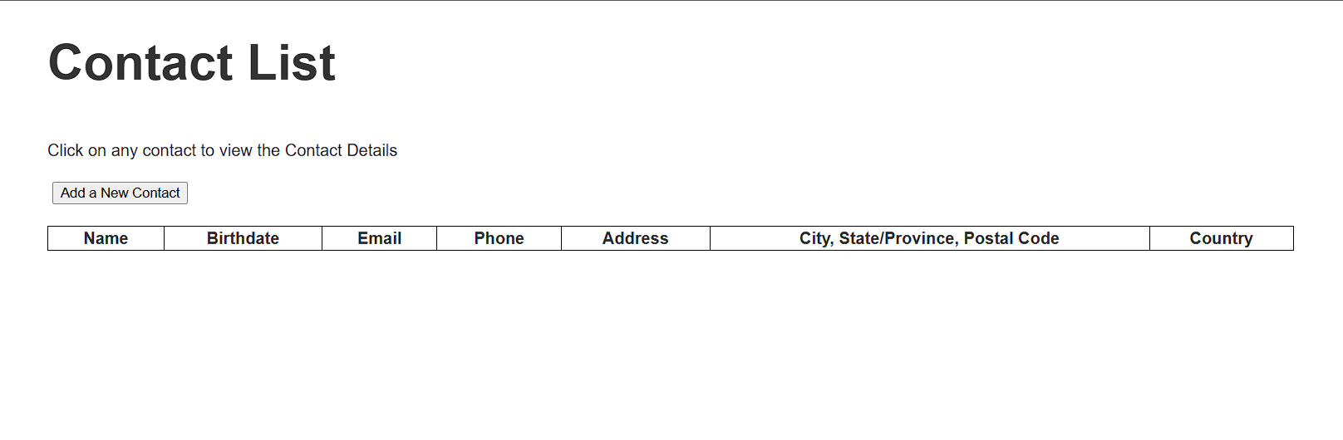

### TC no. 04: Verify the user can successfully edit an existing contact

**Precondition:** Execute TC no. 08



Steps:

1) Click on the row containing the existing contact, on any value.

Verify the Contact Details page opens



2) Click on the Edit contact button

Verify the Edit Contact page opens



3) Click to change or remove any existing value. Click on the submit button

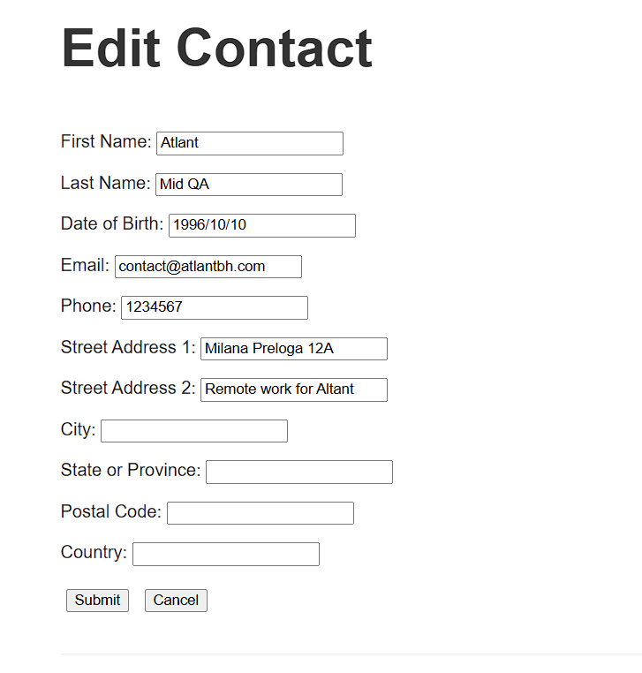

Verify the user is navigated back to the Contact details page and all changes are shown.

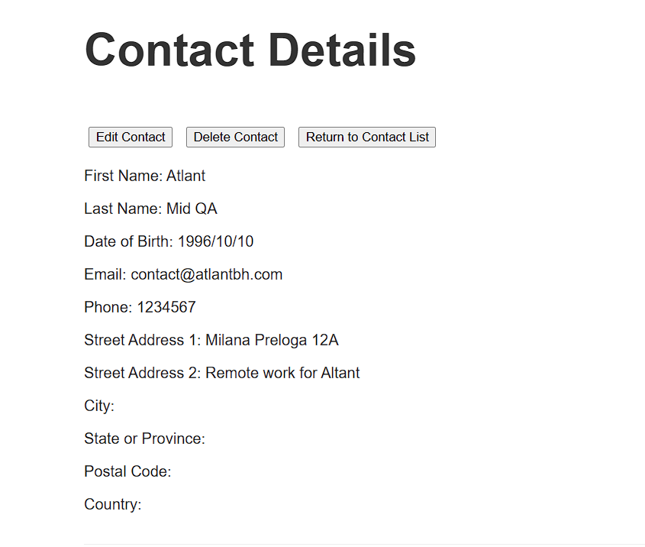

4) Click on the return to contact list button.

Verify user is navigated back to the Contact list page with the table showing new results.  
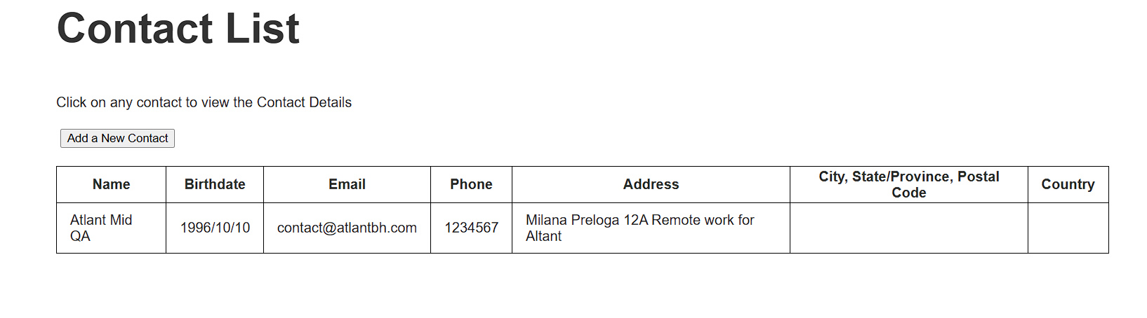

## **Test Documentation info**

**Type of Issue:**

* Functional Bug (F)
* User Interface issue (UI)
* User Experience issue (UX)

**Priority:**

* **High**
* **Medium**
* **Low**

# **Bug report & UI/UX issues:**

## **Issue no. 01: (UX) Adjust the error message for incorrect Log in.**

**Precondition:** The user is not logged in.

**Steps to reproduce the issue:**  
- Open the Contact List App homepage

Data: https://thinking-tester-contact-list.herokuapp.com/

- Click the Submit button

**Results:** An error message “Incorrect username or password” is shown

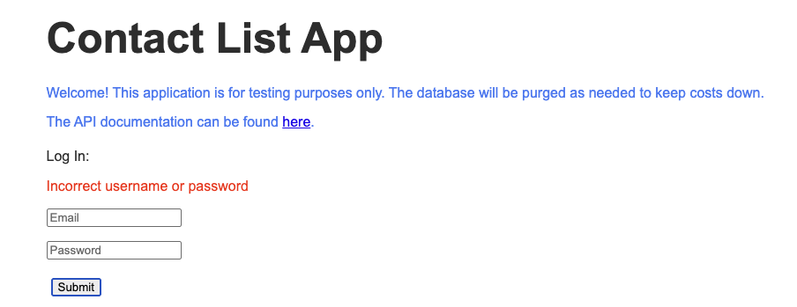  
  
**Expected Results:** As the application is using the email address for the Log in, and also the placeholder value for the first input field is “Email”, we could adjust the error message to “Incorrect email or password”.

## **Issue no. 02: (UX) Adjust the error message for incorrect Sign up.**

**Steps to reproduce the issue:**

- Open the Contact List App homepage

Data: https://thinking-tester-contact-list.herokuapp.com/

- Click on the Sign up button.

- Click on the Submit button.

***Results:*** An error message is shown for missing required fields.

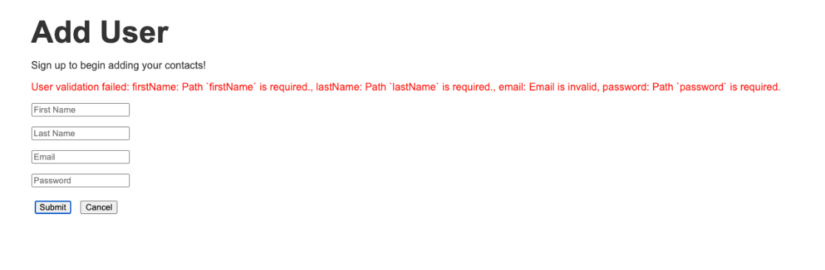  
***Expected results:*** An adjustment should be made, as the current format is inconvenient for the end user, as parts of the message are helpful only to developers (Path, id of the elements). Adjust the message to show only the placeholder names as the missing fields.

## **Issue no. 03 (UX) Add mandatory icons for input fields in Sign up page.**

**Steps to reproduce the issue:**

- Open the Contact List App homepage

Data: https://thinking-tester-contact-list.herokuapp.com/

- Click on the Sign up button.

- Click on the Submit button.

**Results:** An error message is shown for missing required fields.

  
***Expected results:*** As a user**,** I would like to know which input fields are mandatory. For example, the application provides this info on the Add Contact page for the First and Last name.

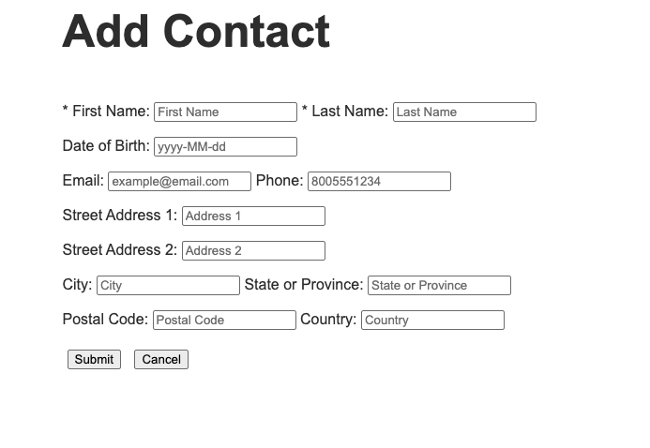

## **Issue no. 04 Provide the user the ability to delete their profile.**

**Description:** Some users want their data to be completely removed once they stop using an application. We could provide this option in the Contact List App application too, for example below the existing “Log out” button.

## **Issue no. 05 User is not able to change their password.**

**Description:** If the user forgets their password, the application does not provide an option to reset it.

## **Issue no. 06 (UX) Add a view icon next to password input fields.**

**Description:** In the Contact List App, the user is provided with the password input field in the Log in and Sign up pages. When the user enters the password, it is automatically hidden, but an option/icon should also be present where for example after the user clicks on it, the entered password will be temporarily visible, and after the release of the mouse click the password is again hidden.

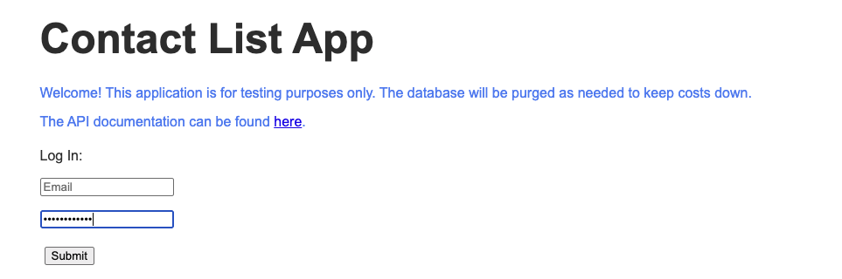

## **Issue no. 07 (UX) Investigate what field values can’t be used for two different contacts.**

**Description:** This is a questionable change, but in the long term, I do not see a reason why someone wants to add two contacts that have the same values for fields that are usually unique to each individual in the real world. In this case, two users can have the same name, birthdate, and location (city, address, country…). But I do not see this happening for the email address and phone number. Both contacts might have access to the same email address, therefore using it. But in my opinion, the general practice is that every unique user or individual should have their own email address and phone number in the long run.

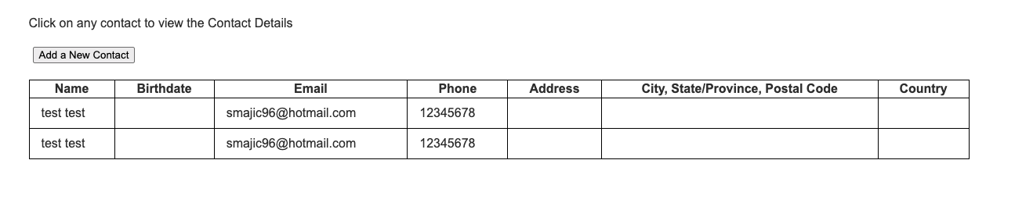

## **Issue no. 08 Logged out users can access the Contact List pages.**

**Precondition:** User is not logged in

**Data:**   
<https://thinking-tester-contact-list.herokuapp.com/contactList>

<https://thinking-tester-contact-list.herokuapp.com/addContact>https://thinking-tester-contact-list.herokuapp.com/editContact

https://thinking-tester-contact-list.herokuapp.com/contactDetails

**Steps to reproduce the issue:**- Open the following link provided from the data  
<https://thinking-tester-contact-list.herokuapp.com/contactList>**Results:** The contact List page opens

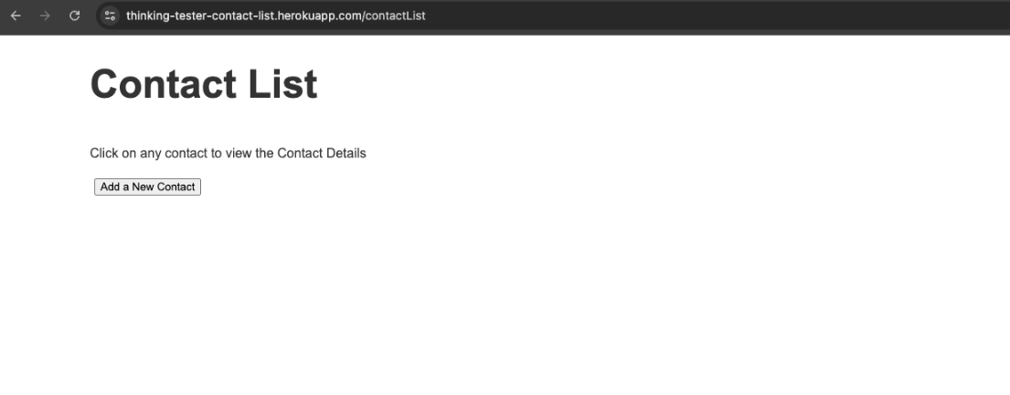

**Expected Results:** The user is navigated to the Login homepage

- Open the following link provided from the data  
<https://thinking-tester-contact-list.herokuapp.com/addContact>**Results:** The Add contact page opens

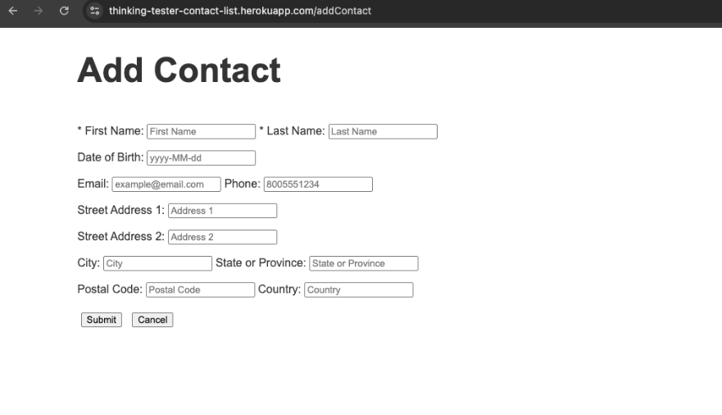

**Expected Results:** The user is navigated to the Login homepage

- Continue adding the first name, last name and click on the Submit button

**Results:** An undefined error message appears

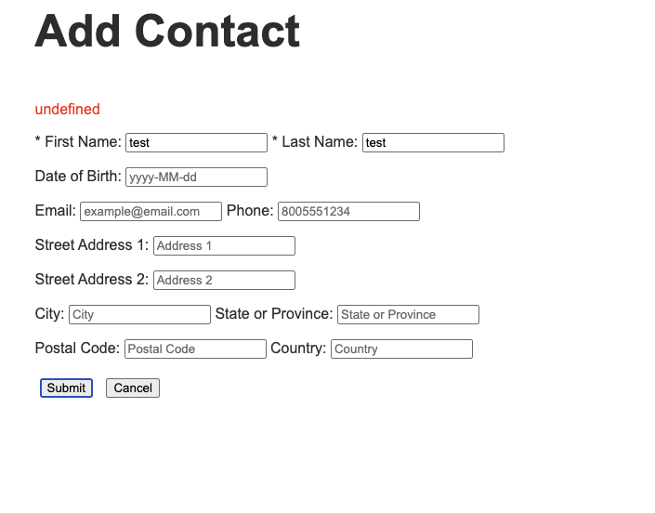

- Open the following link provided from the data  
https://thinking-tester-contact-list.herokuapp.com/editContact  
  
**Results:** The edit contact page opens. Clicking on the submit button results again in the undefined error showing up.

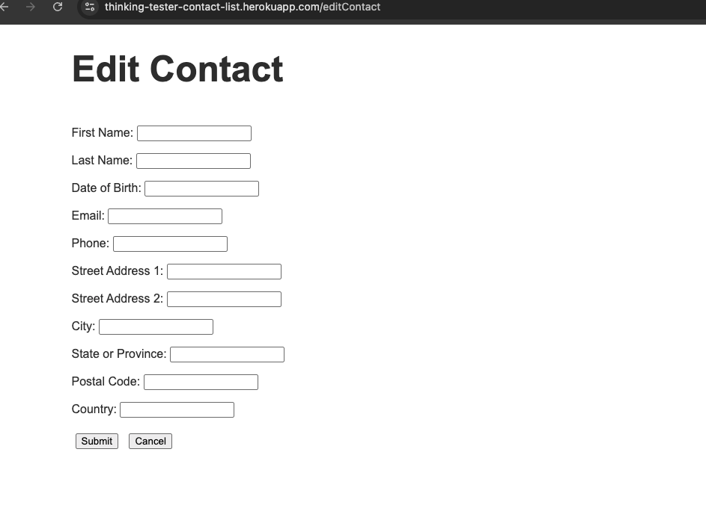

**Expected Results:** The user is navigated to the Login homepage

- Open the following link provided from the data  
https://thinking-tester-contact-list.herokuapp.com/contactDetails  
  
**Results:** The Add contact details page opens. The user can click on any button which transfers the user to all previous pages.

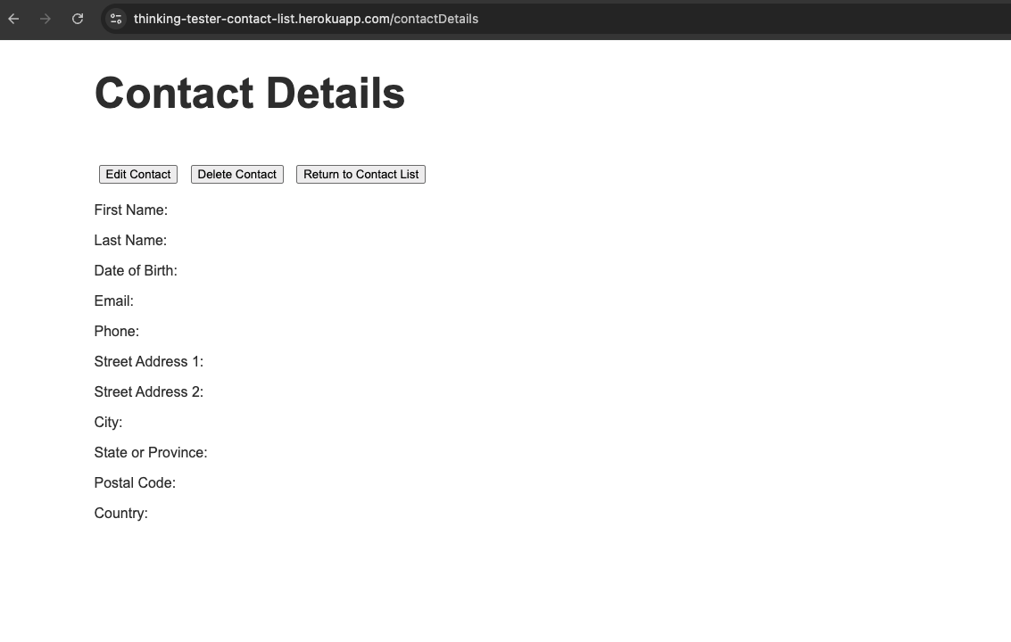

**Expected Results:** The user is navigated to the Login homepage

## **Issue no. 09 (UX) Hide the password value in the Sign-up error message.**

**Steps to reproduce the issue:**

**- Open the Contect List app homepage**

[**https://thinking-tester-contact-list.herokuapp.com/**](https://thinking-tester-contact-list.herokuapp.com/)**- Click on the Sign up button to enter the Sign up page  
- Enter valid values for all input fields, for the password enter less than 6 characters.  
- Click the Submit button**

**Results: An error message appears informing the user about the invalid password length, but at the same time showing the current value, which is a security concern.**

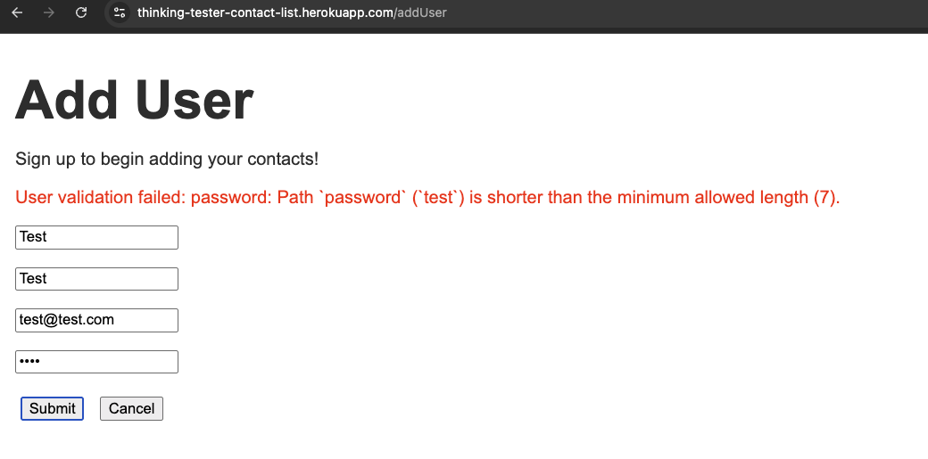

**Expected Results: We should not show the password unless the user explicitly wants to see it.**

## **Issue no. 10 (UX) Change the Date of Birth format for contacts.**

**Description: This is not an issue but a better practice. If we have the choice to choose between only two different formats. One where the year comes at the beginning, and the other where it is at the end, we should choose depending on the format most people in the world are used to.**

**The format where the year comes at the end is mainly used globally, covering most of Europe, Latin America, Africa, USA and parts of Asia.**

